BLE Provisioning

# Introduction

This application notes describes the use of multiple APIs to create a provisioning application using BLE as the mode of transferring provisioning data. The accompanying code sample helps understand BLE provisioning in detail.

# BLE Provisioning

The sample application in this document creates a BLE GATT profile and service which is then used to provision a connection to a Wi-Fi network. An android application running a custom android application is used to input the Wi-Fi credentials.

# Topology

Talaria TWO

BLE Mobile Application

Access Point

BLE

Wi-Fi

Provisioning

Figure : Topology

# List of APIs

1. bt_gap_init():Creates and initializes all the resources needed to run GAP service and must be called before using any of the other functions in the Bluetooth GAP interface.
2. common_server_create():Creates a server with the name, manufacturer name and appearance passed, and creates and adds below services to the created server:
3. Generic Access
4. Generic Attribute
5. Device Information Services

Moreover, common server instance is reference counted. Future calls to this API increment the reference count and returns the instance created in first call.

|  |
| --- |
| void common_server_create(char *name, uint16_t appearance, char *manufacturer_name); |

1. common_server_destroy():Decrements the reference count for common server created by API common_server_create(). If reference count reaches zero, it destroys the server created and frees up all the resources.

|  |
| --- |
| void common_server_destroy(); |

1. bt_gatt_create_service_128(): Creates a service declaration from a 128-bits UUID given as parameter and returns the pointer to the GATT service.
2. bt_gatt_add_char_16(): Adds a characteristic with a 16-bit UUID to a created service.
3. bt_gatt_add_service(): Adds a created service to the local server list.
4. bt_gap_cfg_adv_set(): Configures the advertisement parameters for the GAP peripheral through which the frequency of advertisement transmission in fast and slow mode can be adjusted. It also configures the Tx power for advertisement and the channel map used.
5. bt_gap_addr_set(): Sets address for given address type.
6. bt_gap_connectable_mode(): Sets the device in desired connectable mode.
7. bt_gap_server_link_add(): Used to add a GATT server to the GAP connection.
8. bt_gap_server_link_remove(): Used to remove GATT server from the GAP connection.
9. wcm_create():Create a Wi-Fi network interface.
10. wcm_add_network_profile(): Adds a network profile to WCM.
11. wcm_delete_network_profile(): Deletes the currently active network profile that was previously added.
12. wcm_auto_connect(): Starts or stops auto connect.
13. wcm_notify_enable(): Enables callbacks of link and IP address changes.

# Code Walkthrough

## Overview

The sample code in the path apps\ble_provisioning\src\main.c implements a server called Inno_BLEWiFiProvisioning. It creates and starts a custom GATT service with two write-only characteristics. These characteristics can be written by a connected BLE Client. This allows the BLE Client to send SSID and Passphrase to Talaria TWO. Whenever these characteristics are written by the client, relevant callback is received.

In addition to the custom service, the server also makes use of common server functionality provided by the BLE API. Specifically, this adds the Generic Access, Generic Attribute, and Device Information services to the server.

## Flow Chart

Figure : Flow diagram

GAP initialization

Add custom and common GATT services/characteristics

Start GATT server (Enables advertisement)

No

Yes

BLE connection

Start Wi-Fi connection process with received provisioning data

(SSID, passphrase)

Stop BLE advertising

Yes

Yes

No

No

Receive provisioning data

(SSID, passphrase)

Wi-Fi connection success

## Sample Code Walkthrough

### GAP Initialization

The server starts by initializing the GAP Service:

|  |
| --- |
| bt_gap_init(); |

The GAP API must be initialized before other functions in the GAP interface are called.

### Adding Common GATT Server Functionality

The server uses the this common_server_create() API which creates a server name Inno_BLEWiFiProvisioning with a manufacturer name as Innophase Inc.

|  |
| --- |
| common_server_create("Inno_BLEWiFiProvisioning", 0, "Innophase Inc"); |

### Adding Custom GATT Service & Characteristic

The server’s custom service is created, and characteristics are added to it. The macro function defines the UUIDs of custom characteristics.

|  |
| --- |
| #define UUID_WIFI_SSID_16 0xAB34  #define UUID_WIFI_PASSCODE_16 0xCD34  #define UUID_WIFI_STATUS_16 0xEF34 |

custom_server_create() creates the "custom server" i.e., adds the custom service and characteristic.

|  |
| --- |
| srv.cust_service = bt_gatt_create_service_128(UUID_CUSTOM_SERVICE);  bt_gatt_add_char_16(srv.cust_service, UUID_WIFI_SSID_16, ssid_provision_cb, GATT_PERM_WRITE, GATT_CHAR_PROP_W); bt_gatt_add_char_16(srv.cust_service, UUID_WIFI_PASSCODE_16,  pass_provision_cb, GATT_PERM_WRITE, GATT_CHAR_PROP_W);  bt_gatt_add_char_16(srv.cust_service, UUID_WIFI_STATUS_16,  status_provision_cb, GATT_PERM_READ, GATT_CHAR_PROP_R);  bt_gatt_add_service(srv.cust_service); |

bt_gatt_create_service_128() function creates a GATT service with a 128-bit UUID.

bt_gatt_add_char_16 is used to add a characteristic with a 16-bit UUID to a service.

Callback function is provided as a parameter to this function, which will be called when the characteristic is accessed. Properties and permissions for the characteristic are also specified with this API.

Here, three such characteristics are added.

1. UUID_WIFI_SSID_16 and the callback associated when accessing this characteristic - ssid_provision_cb().
2. UUID_WIFI_PASSCODE_16 and the callback associated when accessing this characteristic - pass_provision_cb().
3. UUID_WIFI_STATUS_16 callback associated when accessing this characteristic - status_provision_cb ()

SSID and PASSCODE, both have WRITE permission and property. STATUS has read permission and property.

Finally, bt_gatt_add_service adds the service to the server.

### Starting BLE GATT Server

Once the server’s services and characteristics are set up, it starts using the start_server function. gap_ops_t gap_ops are the GAP option objects to be passed to GAP functions.

|  |
| --- |
| static const gap_ops_t gap_ops = {  .connected_cb = connected_cb,  .disconnected_cb = disconnected_cb,  .discovery_cb = NULL,}; |

start_server() function initiates Bluetooth provisioning.

|  |
| --- |
| bt_gap_cfg_adv_t bt_adv_handle;  bt_adv_handle.fast_period = 10240;  bt_adv_handle.slow_period = 0;  bt_adv_handle.fast_interval = 160;  bt_adv_handle.slow_interval = 480;  bt_adv_handle.tx_power = 0;  bt_adv_handle.channel_map = BT_HCI_ADV_CHANNEL_ALL;  bt_gap_cfg_adv_set(&bt_adv_handle); |

bt_gap_addr_set() sets the BLE address.

|  |
| --- |
| bt_gap_addr_set(bt_hci_addr_type_random, SERVER_ADDR); |

bt_gap_connectable_mode() makes the server connectable and enables the advertisement.

|  |
| --- |
| bt_gap_connectable_mode(GAP_CONNECTABLE_MODE_UNDIRECT,  bt_hci_addr_type_random, addr_type_zero, address_zero, &gap_ops); |

To allow other devices to connect to the device via Bluetooth, there is a need to start advertising and making the device connectable.

Here, bt_gap_cfg_adv_set sets parameters for advertisement.

The parameters passed for configuring the advertisement are explained as follows:

1. adv_fast_period is set to 10,240ms which is nearest multiple of 10 seconds in 625µs units.

This implies, the fast advertising will be attempted for nearly 10 seconds (10.24s) when the advertisement is enabled, post which the slow advertisement will be attempted.

1. adv_slow_period is set to 0. This implies, slow advertisement will be attempted indefinitely and there is no time bound programmed after which advertisement should stop automatically.
2. adv_fast_int is set to 160, which entails (160*625µs) = 100,000µs = every 100ms is the interval at which fast advertisement will be attempted.
3. adv_slow_int is set to 1,600, which entails (1,600*625µs) = 1,000,000µs = once in every second will be the interval of slow advertising.
4. bt_gap_set_adv_data sets the advertisement data. It is for legacy advertisement.
5. bt_gap_addr_set sets the BLE address and address type. The sample server uses a random address that does not change.
6. bt_gap_connectable_mode makes the device connectable and enables advertisement.

**Note**: A pointer to gap_ops_t instance is provided to this function call. This supplies the GAP callback functions connected_cb and disconnected_cb to be used when a connection or disconnection event occurs.

At this stage, it is suitable to accept the provisioning data from companion smartphone application and wait for the provisioning to complete.

|  |
| --- |
| int main(void)  {  . . .  . . .  start_server();  //while(1), to be 'continued-in' for restarting prov after failure / timeout  // or to be 'breaken-out' for the prov success case  while(1)  {  os_printf("Inno_Ble_WiFiProvisioning started\n");  while(!ssid_provisioned || !pass_provisioned)  os_msleep(1000);  wifi_main(ssid, pw);  . . .  }  . . .  } |

### BLE Connection/Disconnection Callbacks

At this point in the execution of server, it is advertising and ready to receive a connection from the client. When the client connects, the callback function connected_cb will be called. In the callback, the GATT server needs to be linked to this GAP connection using bt_gap_server_link_add()with the following function call:

|  |
| --- |
| srv.gatt_link = bt_gap_server_link_add(param->handle); |

The sample code provides details on how to obtain the argument required for this function call from the argument provided to the callback by casting hci_event with bt_hci_evt_le_conn_cmpl_t and fetching its handle.

Similarly, the link is removed in the callback function that is called when the client disconnects disconnected_cb, using bt_gap_server_link_remove():

|  |
| --- |
| bt_gap_server_link_remove(srv.gatt_link); |

At disconnected_cb, if either the SSID or Passphrase was not received, then the server is made connectable again. The bt_gap_connectable_mode() makes server connectable again (will re-enable advertisement).

|  |
| --- |
| if(!ssid_provisioned || !pass_provisioned)  {  bt_gap_connectable_mode(GAP_CONNECTABLE_MODE_UNDIRECT, bt_hci_addr_type_random, 0, address_zero, &gap_ops);  } |

### BLE Characteristic Access Callback

While the client is connected to the server, it can read or write the custom characteristic based on characteristic’s properties. This results in the callback function associated with the characteristic being called.

When the write only characteristic UUID_WIFI_SSID_16 is accessed, the callback associated when accessing this characteristic ssid_provision_cb() is called. BLE GATT Server receives this text messages from BLE Client and stores it as SSID. The bt_att_error_t and ssid_provision_cb() callback functions are called when the custom characteristic is accessed.

|  |
| --- |
| static bt_att_error_t ssid_provision_cb(uint8_t bearer, bt_gatt_fcn_t rw, uint8_t *length, uint8_t offset, uint8_t *data)  {  if(offset != 0)  return BT_ATT_ERROR_INVALID_OFFSET;  ssid_provisioned = 1;  memset(ssid, 0 , 32);  memcpy(ssid, data, *length);  return BT_ATT_ERROR_SUCCESS;  } |

When the write only characteristic UUID_WIFI_PASSCODE_16 is accessed, the callback associated when accessing this characteristic pass_provision_cb() is called. BLE GATT server receives this text messages from BLE Client and stores it as Password.

bt_att_error_t and pass_provision_cb() callback functions are called when the custom characteristic is accessed.

|  |
| --- |
| static bt_att_error_t pass_provision_cb(uint8_t bearer, bt_gatt_fcn_t rw, uint8_t *length, uint8_t offset, uint8_t *data)  {  if(offset != 0)  return BT_ATT_ERROR_INVALID_OFFSET;  pass_provisioned = 1;  memset(pw, 0 , 32);  memcpy(pw, data, *length);  return BT_ATT_ERROR_SUCCESS;  } |

Once both the callbacks are received, both the flags pass_provisioned and ssid_provisioned are true, the program progresses to the next step. Talaria TWO then tries to connect to the provisioned SSID.

When the read only characteristic UUID_WIFI_STATUS_16 is accessed, the callback associated when accessing this characteristic status_provision_cb() is called.

This is used by the smartphone enquire about the status of the connection attempt to AP.

A waiting, success, failure, or timeout status is passed as a string to the smartphone reading this characteristic, based on the present state. Few variables for keeping the states are also updated here.

bt_att_error_t and status_provision_cb() callback functions are called when the custom characteristic is accessed.

|  |
| --- |
| static bt_att_error_t status_provision_cb(uint8_t bearer, bt_uuid_t *uudid, bt_gatt_fcn_t rw, uint8_t *length, uint16_t offset, uint8_t *data)  /* Writes to this characteristic not allowed */  if (rw != BT_GATT_FCN_READ)  return BT_ATT_ERROR_WRITE_NOT_PERMITTED;  if(offset != 0)  return BT_ATT_ERROR_INVALID_OFFSET; |

If status_flag is 1, it implies that the IP address is received.

|  |
| --- |
| if(status_flag)  {  memset(status, 0 , 16);  memcpy(status, STATUS_SUCCESS, STATUS_SUCCESS_LENGTH);  *length =STATUS_SUCCESS_LENGTH;  status_sent = 1;  os_printf("client reading status : success\n");  } |

If wcm_return is 0 and the status_flag is 0 it then waits for a notification.

|  |
| --- |
| else  {  if(wcm_return == 0)  {  if(link_down_timeout == 0) /* linkdown timer has not Timedout */  {  os_printf("client reading status:waiting\n");  *length =STATUS_WAITING_LENGTH;  } |

In this case, keep status_sent to zero only and use timeout_sent instead.

|  |
| --- |
| else /* linkdown timer timedout */  {  /* memcpy "timeout" as status, */  memset(status, 0 , 16);  memcpy(status, STATUS_TIMEOUT, STATUS_TIMEOUT_LENGTH);  *length =STATUS_TIMEOUT_LENGTH;  os_printf("client reading status : timeout\n");  timeout_sent = 1;  }  } |

If WCM returns any value, it leads to the client reading failure case.

|  |
| --- |
| else /* non zero wcm_return --> failure */  {  memset(status, 0 , 16);  memcpy(status, STATUS_FAILURE, STATUS_FAILURE_LENGTH);  *length =STATUS_FAILURE_LENGTH;  status_sent = 1;  os_printf("client reading status:failure\n");  }} |

memcpy() copies the status failure length and stores it in data.

|  |
| --- |
| memcpy(data, status, *length);  return BT_ATT_ERROR_SUCCESS; |

### Connecting to the Provisioned Wi-Fi network

To connect to a Wi-Fi network, wcm_create(), wcm_add_network() and wcm_auto_connect()APIs from WCM are used. SSID and Password from section 7.3.6 are passed here.

wcm_notify_enable() is used to register notification callbacks for link-up, link-down and IP address changes. Based on these notification, connection success or timeout is decided.

A housekeeping structure for a timer is created for managing a timeout case in connection attempt.

**wifi_control.c**

wcm_create() creates the Wi-Fi network interface. wcm_notify_enable() enables the callbacks of link and IP address changes.

|  |
| --- |
| h = wcm_create(NULL);  wcm_notify_enable(h, my_wcm_notify_cb, NULL);  if( h == NULL ){  os_printf(" failed.\n");  return -1;  } |

wcm_add_network() adds the network which must be added initially. It can fail due to the following reasons: already busy, no memory or poorly formatted password.

|  |
| --- |
| #ifdef WIFI_CONNECT_USE_DEPRECATED_WCM_API  status = wcm_add_network(h, ssid, NULL, pw);  os_printf("add network status: %d\n", status);  if(status != 0){  os_printf("adding network Failed\n");  return status;  } |

struct network_profile creates a Network Profile.

network_profile_new_from_file_system() creates a Network Profile from a configuration file in the file system.

network_profile_new_from_ssid_pw() creates a Network Profile using BOOT ARGS. In case of an error, the error messages are printed on console.

|  |
| --- |
| #else /* WIFI_CONNECT_USE_DEPRECATED_WCM_API */  /*"/sys/nprofile.json"*/  const char *np_conf_path = os_get_boot_arg_str("np_conf_path")?: NULL;  struct network_profile *profile;  if (np_conf_path != NULL) {  status = network_profile_new_from_file_system(&profile, np_conf_path);  } else {  status = network_profile_new_from_ssid_pw(&profile, ssid, pw);  }  if (status < 0) {  pr_err("could not create network profile %d\n", status);  return status;  }  status = wcm_add_network_profile(h, profile);  if (status < 0) {  pr_err("could not associate network profile to wcm %d\n", status);  return status;  } |

wcm_auto_connect() starts and stops the auto connection function.

|  |
| --- |
| #endif /* WIFI_CONNECT_USE_DEPRECATED_WCM_API */  os_printf("added network successfully, will try connecting..\n");  status = wcm_auto_connect(h, 1);  os_printf("connecting to network status: %d\n", status);  if(status != 0){  os_printf("trying to connect to network Failed\n");  return status;  } |

This start connection attempts the timer which times out in TIMER_TIMEOUT_SEC_IN_MICRO seconds.

|  |
| --- |
| if(ptimer_user_data->timer_running == 0)  {  ptimer_user_data->timeout = os_systime()+(TIMER_TIMEOUT_SEC_IN_MICRO); |

This sets the timer callback and user data.

|  |
| --- |
| ptimer_user_data->timer_id = os_timer_allocate(TIMER_BASE_US,  TIMER_ANY, on_timer_event_callback, ptimer_user_data); |

os_timer_set() function starts the timer for required timeout. The timeout value is in microseconds.

|  |
| --- |
| os_timer_set(ptimer_user_data->timer_id, ptimer_user_data->timeout);  ptimer_user_data->timer_running = 1;  connection_attempt_timeout = 0;  os_printf ("\n connection attempt timer started. current time"  "in microseconds:[%u] \n", os_systime());  } |

In the my_wcm_notify_cb(), the timer is allocated using os_timer_allocate() and starts using os_timer_set() whenever a link-down is received and if the timer was not already running.

When the connection is later successful and a link-up occurs, this timer is cancelled if it was already running using os_timer_reset().

If the timer is not cancelled by link-up before the timeout occurs, then it is considered a connection trial time-out case. The timeout for this timer can be set using #define TIMER_TIMEOUT_SEC_IN_MICRO which by default is set to 8 seconds.

Few variables for keeping the states are also updated here:

|  |
| --- |
| static void my_wcm_notify_cb(void *ctx, struct os_msg *msg)  {  switch(msg->msg_type)  {  case(WCM_NOTIFY_MSG_LINK_UP):  os_printf("wcm_notify_cb to App Layer - WCM_NOTIFY_MSG_LINK_UP\n");  break;  case(WCM_NOTIFY_MSG_LINK_DOWN):  os_printf("wcm_notify_cb to App Layer - WCM_NOTIFY_MSG_LINK_DOWN\n");  break;  case(WCM_NOTIFY_MSG_ADDRESS):  os_printf("wcm_notify_cb to App Layer - WCM_NOTIFY_MSG_ADDRESS\n");  break;  case(WCM_NOTIFY_MSG_DISCONNECT_DONE):  os_printf("wcm_notify_cb to App Layer - WCM_NOTIFY_MSG_DISCONNECT_DONE\n");  break;  case(WCM_NOTIFY_MSG_CONNECTED):  os_printf("wcm_notify_cb to App Layer - WCM_NOTIFY_MSG_CONNECTED\n");  status_flag = true;  /* if active, then the connection_attempt timer STOPS here */  if(ptimer_user_data->timer_running == 1)  {  os_timer_reset(ptimer_user_data->timer_id);  ptimer_user_data->timer_running = 0;  os_printf ("\n Cancelling the connection timeout timer. current time"  "in microseconds:[%u] \n", os_systime());  /* purpose of the timer is fulfilled, release it here */  os_timer_release(ptimer_user_data->timer_id);  }  break;  default:  break;  }  os_msg_release(msg);  } |

If the timer is not cancelled before the programmed timeout, then a timer callback occurs where a flag is set indicating this scenario. Connection attempt timer's callback sets a flag to be used by att read cb and for the app_main to behave accordingly.

|  |
| --- |
| static void on_timer_event_callback(void *user_data)  {  os_printf("\n Timeout Event occured.\n");  ptimer_user_data->timer_running = 0;  /* purpose of the timer is fulfilled, release it here */  os_timer_release(ptimer_user_data->timer_id);  connection_attempt_timeout = 1;  } |

wcm_delete_network_profile() deletes the currently active network profile that was previously added.

|  |
| --- |
| #ifndef WIFI_CONNECT_USE_DEPRECATED_WCM_API  wcm_delete_network_profile(h, NULL);  #endif |

This cleans the ptimer_user_data.

|  |
| --- |
| if(ptimer_user_data!= NULL)  {  os_free(ptimer_user_data);  ptimer_user_data = NULL;  } |

wcm_destroy() function shuts down and cleans up a Wi-Fi Connection Manager interface.

|  |
| --- |
| wcm_destroy(h); |

**main.c**

In main(), after calling wifi_main(), the return from this function and the state changes from callbacks on_timer_event_callback() and my_wcm_notify_cb() are used to decide if the connection attempt was successful, failed or timed-out.

If the attempt results in error, failure or timeout then the relevant status is sent to the smartphone app when it enquires, and the provisioning loop starts again.

Once the Wi-Fi connection is successful, the BT GATT and GAP resources are destroyed using common_server_destroy() and bt_gap_destroy(), and T2 stops advertising for BLE connection.

In every step when status change happens, it is made sure that the status has been read by smartphone app using status_provision_cb() before going to next state.

|  |
| --- |
| int main(void)  status_flag = false;  memset(status, 0 , 16);  memcpy(status, STATUS_WAITING, STATUS_WAITING_LENGTH); |

bt_gap_init() initiates the Bluetooth GAP service.

|  |
| --- |
| bt_gap_init(); |

The common server implements the following services that will be added to the server. The services are Generic Access, Generic Attribute and Device information.

|  |
| --- |
| common_server_create("Inno_Ble_WiFiProvisioning", 0, "Innophase Inc"); |

As we are restarting provisioning, reset the housekeeping state variables and status message to default value waiting.

|  |
| --- |
| memset(status, 0 , 16);  memcpy(status, STATUS_WAITING, STATUS_WAITING_LENGTH);  status_sent = 0;  timeout_sent = 0;  connection_attempt_timeout = 0;  wcm_return = 0;  continue; |

If connection_attempt_timeout happens before connection success, then continue to while(1) loop after resetting the flags: ssid_provisioned, pass_provisioned and executing wifi_destroy. In this case, the status message sent is STATUS_TIMEOUT and the flag timeout_sent is used to confirm that the status STATUS_TIMEOUT has been sent to the client.

|  |
| --- |
| if(connection_attempt_timeout == 1)  {  /*connection attempt timed-out. also, status_sent is 0 in timeout case */  os_printf("int main -- WiFi Connection not succesfull"  " because connection attempt timed-out \n");  /* make sure status timeout is sent, before starting prov again */  while(!timeout_sent)  {  os_msleep(1000);  }  wifi_destroy(0); |

Since provisioning is restarting, reset the housekeeping state variables and status message to default value waiting. Continue to the provisioning loop after resetting ssid_provisioned, pass_provisioned and housekeeping state variables.

|  |
| --- |
| ssid_provisioned = 0;  pass_provisioned = 0;  connection_attempt_timeout = 0;  wcm_return = 0;  memset(status, 0 , 16);  memcpy(status, STATUS_WAITING, STATUS_WAITING_LENGTH); |

This starts provisioning again, hence reset the remaining housekeeping state variables.

|  |
| --- |
| timeout_sent = 0;  status_sent = 0 |

This function destroys the common server and the Bluetooth GAP service.

|  |
| --- |
| common_server_destroy();  bt_gap_destroy(); |

my_app_init() function starts the app here.

|  |
| --- |
| my_app_init(); |

After successful connection, another application thread is created for example purposes where the application logic can be run.

|  |
| --- |
| static void my_app_init()  {  my_app_thread = os_create_thread("my_app_thread", (void *) my_app_thread_func,  NULL, MY_APP_THREAD_PRIO, MY_APP_THREAD_STACK_SIZE);  if( my_app_thread == NULL ){  os_printf(" thread creation failed\n");  return;  }  os_join_thread(my_app_thread); } |

# Running the Application

## Program Talaria TWO

Program ble_provisioning.elf(sdk_x.y\apps\ble_provisioning\bin) using the Download tool(sdk_x.y\pc_tools\Download_Tool) provided with InnoPhase Talaria TWO SDK.

1. Launch the Download tool provided with InnoPhase Talaria TWO SDK.
2. In the GUI window:
   1. Boot Target: Select the appropriate EVK from the drop-down
   2. ELF Input: Load the ble_provisioning.elf by clicking on Select ELF File.
   3. Programming: Prog RAM or Prog Flash as per requirement.

For more details on using the Download tool, refer to the document: UG_Download_Tool.pdf (path: *sdk_x.y\pc_tools\Download_Tool\doc*).

**Note**: x and y refer to the SDK release version. For example: sdk_2.4/doc.

## Using InnoPhase Talaria TWO Smart Home Android Application

To test this sample application, we will need to use the companion Innophase T2 Smart Home Android application on an android device.

1. To install, open the provided .apk file (sdk_x.y\apps\ble_provisioning\mobile_app) in the android directory or build the android project using Android Studio.
2. To connect to the Talaria TWO BLE Server, wait for the application to complete the scanning and look for Inno_Ble_WiFiProvisioning and click on it.

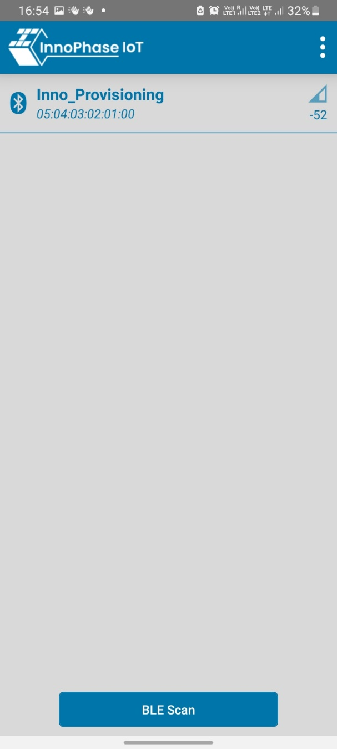

Figure : Scanning for Talaria TWO BLE Server for Wi-Fi Provisioning

Android phone connects as a BLE Client to Talaria TWO device at this stage.

1. Android application scans for the nearby available Wi-Fi networks and displays them in a list view.

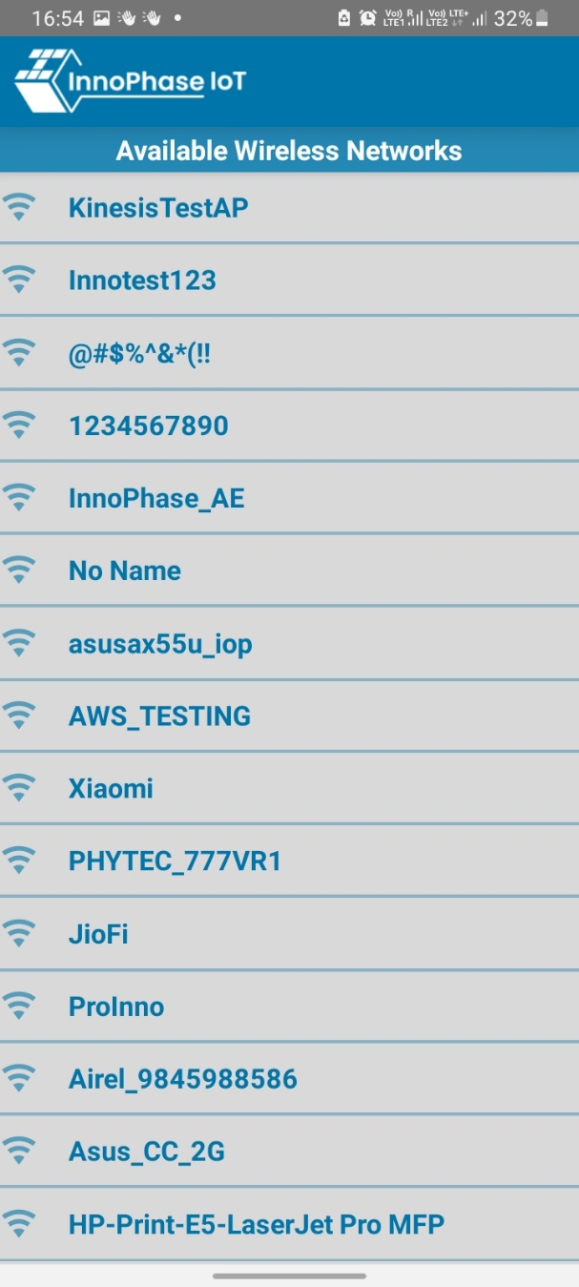

Figure : Available Wi-Fi networks as scanned by Android Phone

1. Select the SSID of the AP you want to connect to and provide the passphrase.

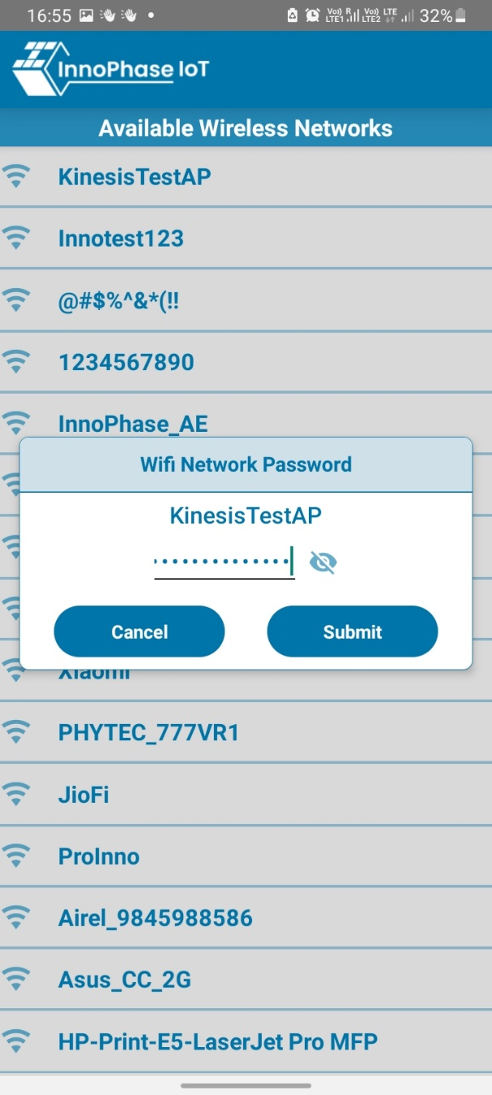

Figure : Providing the passphrase

1. Once the passphrase is entered, click on Done. If the provided passphrase is correct, connection will be established successfully. If not, an error message is shown.

Figure : Connecting successful

Figure : Error in connection

1. On establishing the connection successfully, the android application should transfer the Wi-Fi credentials using custom GATT Service and Characteristics we created.

Figure : Connection successful

# Expected Output

Talaria TWO will try to connect to the provisioned network and provide the following console output:

|  |
| --- |
| UART:NWWWWWWAE4 DWT comparators, range 0x8000  Build $Id: git-33c6d3fa5 $  app=gordon  flash: Gordon ready!  Y-BOOT 208ef13 2019-07-22 12:26:54 -0500 790da1-b-7  ROM yoda-h0-rom-16-0-gd5a8e586  FLASH:PNWWWWAE4 DWT comparators, range 0x8000  Build $Id: git-33c6d3fa5 $  Inno_Ble_WiFiProvisioning started  [23.887,073] BT connect[0]: ia:79:49:1f:f3:24:87 aa:05:04:03:02:01:00 phy2:0/0 phyC:00  Client connected  client reading status:waiting  WiFi Details SSID: InnoPhase_AE_AP, PASSWORD: innophaseae  addr e0:69:3a:00:15:c2  Connecting to WiFi...  added network successfully, will try connecting..  connecting to network status: 0  connection attempt timer started. current timein microseconds:[25245506]  [25.902,728] CONNECT:98:da:c4:73:b7:76 Channel:2 rssi:-46 dBm  wcm_notify_cb to App Layer - WCM_NOTIFY_MSG_LINK_UP  wcm_notify_cb to App Layer - WCM_NOTIFY_MSG_ADDRESS  [25.953,426] MYIP 192.168.0.164  [25.953,706] IPv6 [fe80::e269:3aff:fe00:15c2]-link  wcm_notify_cb to App Layer - WCM_NOTIFY_MSG_CONNECTED  Cancelling the connection timeout timer. current timein microseconds:[25953775]  client reading status : success  status sent to phone app, now calling common_server_destroy and bt_gap_destroy  starting app_thread |